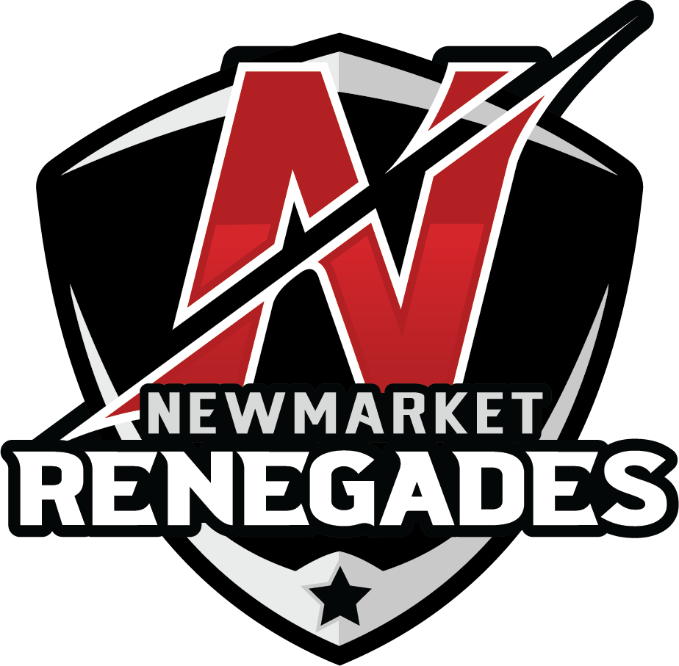

NMHA
Return to Hockey
Parents Meeting

Agenda

• Introductions and Overview
• Safety Protocols
• Highlights - OHF Return to Play Framework
•NMHA Program for 2020-21
o Season Structure
o Coaches and Trainers
o Registration
o Fees & Payment
• Questions and Answers

Introductions & Overview

• NMHA President o Lynda Carusi
• NMHA Vice President o Melissa Di Gaetano
• HL Alt Junior Division o Joey Wilson
• HL Alt Senior Division o Darren Trussler
• Past President o Murray Taylor (Facilitator)

• Please use the Q&A box for questions. We will take questions at the end of the presentation and do our best to address as many as we can in the time we have.

Safety Protocols
• Working with the Town on Safety Protocols
• To start No spectators will be allowed in, will be re-assessed as time progresses according to Ontario Government protocols
• Parents will be able to tie their child’s skates then leave or wait in the car.
• Max. of 6 in a dressing room to start the season and chairs will be placed near the ice surface, come dressed (except for skates/helmet), with filled labelled water bottle, mask and a labelled paper bag to put their mask in when on the ice.
• Must wear mask at all times (except when on ice)
• Allowed access 15 min prior to ice time, no late arrivals
• Must complete a health check 2 hours prior to arriving ePact App. (on-line)
• All safety protocols in the NMHA Return to Hockey document is posted on website.
Highlights – OHF Return to Play
• Multi-stage approach to return to hockey safely
• At this time no tryouts, travel, tournaments, championships.
• Stages are expected to progress in 4 week cycles
• Currently Stage 3B
o NMHA Return to Play Plan has been OMHA approved to proceed
• Physical distancing is required on ice
• No prolonged or deliberate contact
• Player bubbles with no more than 50 players
• Players can only belong to one player bubble, no APs
• No affiliation or integration allowed between leagues
• Tiered structure based on category of participation last year
• Players can play with the association they belonged to in 2019/20 or can return to play in their home centre
• No new player movement for 2020/21 season
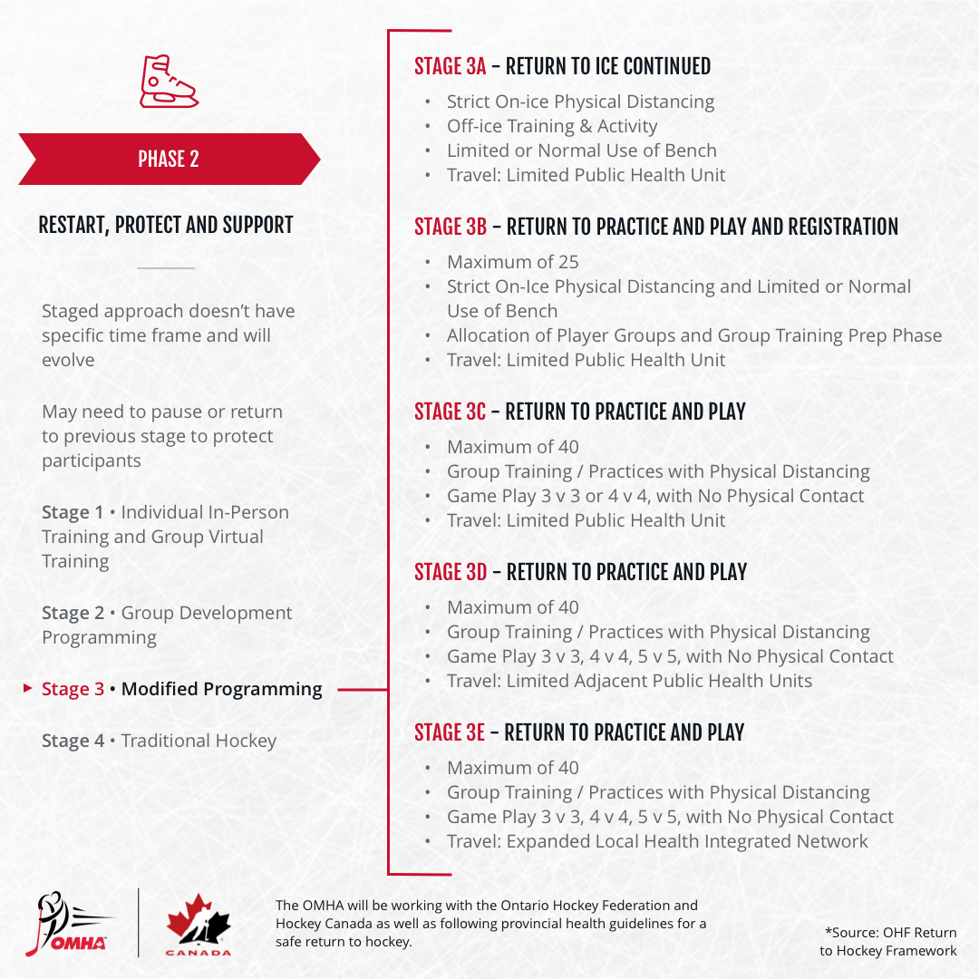

NMHA 2020/21 Season Structure
• All teams internal within NMHA to start
• Focus is on a fun and safe gradual return to play
• Divisions will consist of the following combined age groups
o U7 = U5 & U7 o U8 o U9
o U11 = U10 & U11 o U13 = U12 & U13
o U15 = U14 & U15 o U17 = U16 & U17
oU21 = U18, U19, U19, U20, & U21
• U11 & below structure will follow Hockey Canada/OHF Player Pathways
• U7 – U9 starts Oct 1st to mid-March
• U11 and above start Sept 21st to mid-March

NMHA 2020/21 Season Structure
Each bubble will have 4 teams*
o Teams = 9 players + 1 goalie
• Two Tiers of bubbles in U7 & older divisions
• U7 only 8 players per team
o Tier 1 = 2019/20 A/AA/AAA players
o Tier 2 = 2019/20 HL/LL players (including Select)
• May need to move some players to fill a Tier
• Player movement between tiers and formation of teams to be determined by Rep and House League executives.
• Teams to be decided between Sept 14th and 17th, will be mix of major and minor aged players, coach will notify prior to first ice time
• No player or coach requests will be considered or than siblings.
* Some bubbles may have 5 teams due to fewer players in that division.
NMHA 2020/21 Season Structure
Fees based on 1 practice and 1 game per week o U11 & below may vary due to Player Pathways
o U16 - U21 after development weeks will play 2 games, no practices.
• Practices – 50 minutes on ice
• Games – 50 minutes on ice
o 5 minute warm up, 2 x 22 minute runtime periods
o 4 vs 4 format (sometimes may need to be 3 vs 3)
o no faceoffs, teams change on the fly
- Penalties – 2min = 1 penalty shot
- 4min = 2 penalty shots
- Con-incidental penalties - no penalty shot
- Goals – Team that scores must clear the zone till the other team advances the puck past center ice.
- Offsides – The team must exit the zone will the other team advances the puck past center.
- Goaltender Freezes the Puck – the attacking team (all players) must exit the zone before re-entering.
- Icing – Change of possession. The team that iced the puck must allow the other team to advance the puck past center.

Coaches and Trainers

• Each team must have a Head Coach & Trainer
o Only Head Coach and Trainer are required to be rostered initially
o Additional bench staff may be rostered to help with practices
o At games only 1 coach and a shared trainer to allow for social distancing
• Safe Return to Hockey on-line course must be completed
• Modified qualification requirements for season
• Coach clinics are now available on the OMHA website

• All qualifications listed are the MINIMUM REQUIREMENT
• All Team Officials (Coach, Trainer & Manager) require Respect in Sport (RIS) - Activity Leader or Speak Out!
• All Team Officials (Coach, Trainer & Manager) require Gender Identity & Expression Course
• New for 2020-2021 - All Team Officials (Coach, Trainer & Manager) require Hockey University – Planning a Safe Return to Hockey
• All qualifications must be registered with the OMHA

QUESTIONS

